Health and Wellbeing Policy
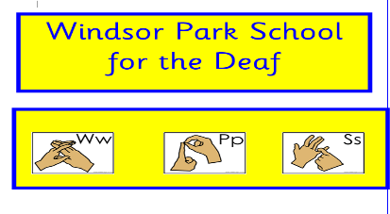

Performance Indicators
HGIOS4 Quality Indicators | 2.4  2.5  2.7  3.1 | Personalised support  Family learning  Partnerships  Ensuring wellbeing, equality and inclusion.

Contents
- Rationale
- Aims
- What does the health and wellbeing framework mean for Teachers of the Deaf?

- How is the health and wellbeing framework structured at Windsor Park?

- Health and wellbeing across learning: the responsibilities of all practitioners

- Focused programmes

- Partnership working across sectors and services

- Personal support for children and young people

- What factors need to be taken into account in planning for health and wellbeing at Windsor Park?

- What features are required to effectively promote health and wellbeing at Windsor Park?

- What are broad features of assessment in health and wellbeing?

- How is personal safety addressed at Windsor Park?

- What is the contribution of physical education, physical activity and sport to health and
wellbeing?

- How can a whole school approach to food and health contribute to health and
wellbeing?

- How do Windsor Park staff make connections within and beyond health and wellbeing?

- Summary

- Rationale

At Windsor Park, our pupils follow Curriculum for Excellence which has an important role to play in promoting the health and wellbeing of children and young people. Our staff deliver this through Total Communication and our Teachers of the Deaf have, or are working towards, an additional qualification in teaching D/deaf learners and understand the significant implications this has on health and wellbeing, e.g. those who are D/deaf are twice as likely to develop mental health issues compared to their hearing peers.

This policy has been adapted from Education Scotland’s “Health and wellbeing Principles and Practice” and is closely related to the Guidance on the Schools (Health Promotion and Nutrition) (Scotland) Act 2007 (http://www.scotland.gov.uk/Topics/Education/Schools/HLivi/foodnutrition).

“Children have the right to good quality health care, to clean water and good food.”
Article 24 of the UNCRC says that healthcare for children and young people should be as good as possible, but also goes further than this by saying children and young people have the right to be both physically and mentally fulfilled.
Article 24 also says that children and young people have a right to information about their health. They should have a say in how they get this and be able to say what they like and dislike about the information they get. (https://www.unicef.org.uk/child-rights-partners/wp-content/uploads/sites/3/2016/08/CRC_summary_leaflet_Child_Rights_Partners_web_final.pdf )

- Aims

In Windsor Park School’s nurturing environment, learning in health and wellbeing ensures that D/deaf children and young people develop the knowledge and understanding, skills, capabilities and attributes which they need for mental, emotional, social and physical wellbeing now and in the future in both hearing and Deaf communities.

Learning through health and wellbeing enables D/deaf children and young people to:

• make informed decisions in order to improve their mental, emotional, social and physical wellbeing
• experience challenge and enjoyment
• experience positive aspects of healthy living and activities for themselves
• apply their mental, emotional, social and physical skills to pursue a healthy lifestyle
• make a successful transition to the next stage of education or work
• establish a pattern of health and wellbeing which will be sustained into adult life, and which will help to promote the health and wellbeing of the next generation of Scottish children.

At Windsor Park we aim to recognise, nurture and support talent which may enable some of our learners to perform at high levels in sport or prepare for careers within the health and leisure industries.

- What does the Health and Wellbeing framework mean for Teachers of the Deaf?

The statements of experiences and outcomes in health and wellbeing reflect a holistic approach to promoting the health and wellbeing of all D/deaf children and young people. They are consistent with the United Nations Convention on the Rights of the Child, which sets out the right for all children and young people to have access to appropriate health services and to have their health and wellbeing promoted. They build on the considerable work of Health Promoting Schools, supported by Falkirk Council. D/deaf children and young people should feel happy, safe, respected and included in the school environment and all staff should be proactive in promoting positive behaviour in the classroom, playground and the wider school community. Windsor Park’s Positive Relationship Policy ensures safety and wellbeing is embedded into our practice, alongside the 6 principles of nurture.

- Children's learning is understood developmentally | - We all need different things to help us learn and grow
- The classroom offers a safe base | - We are safe in school
- The importance of nurture for the development of wellbeing | - We work together, share and care. I am valued, everyone is valued
- Language is a vital means of communication | - We use Total Communication
- All behaviour is communication | - We can show our feelings in different ways. People in school will support us
- The importance of transition in children's lives | - We know what happens every day in school

At Windsor Park School we recognise the importance of strategies such as; peer support, use of visuals and positive behaviour strategies, buddies, and promotion of clubs, safe areas, mentors, support for learning assistants and extended support agencies such as Educational Psychologists and making use of other organisations such as Relax Kids, National Deaf Children’s Society and Outdoor Education.

At Windsor Park School we recognise positive health and wellbeing is central to effective learning and preparation for successful independent living. This aspiration for every D/deaf child and young person in our care can only be met through a concerted approach: our school and our partnerships working together closely to plan their programmes for health and wellbeing explicitly, taking account of our unique circumstances and our learner’s individual needs.

At Windsor Park, all staff are aware of their role and responsibilities in ensuring good health and wellbeing for all within our community.

The diagram below illustrates this shared vision and common goal in Windsor Park and across all Scottish schools.

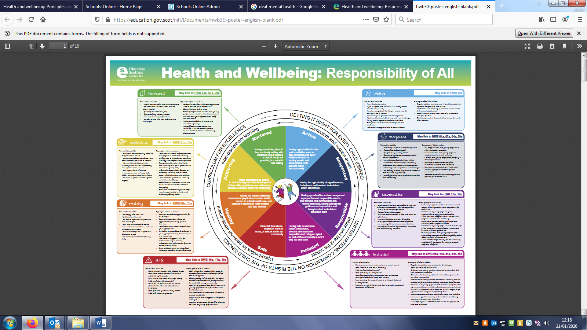

Learning through health and wellbeing promotes confidence, independent thinking and positive attitudes and dispositions. Because of this, it is the responsibility of every teacher to contribute to learning and development in this area.
Building the Curriculum 1
- How is the Health and Wellbeing framework structured at Windsor Park?

Windsor Park’s positive ethos and the relationships we foster with our children and young people are the foundation in ensuring the carefully planned activities. These promote an active, healthy lifestyle, all work towards supporting and nurturing the health and wellbeing of D/deaf children and young people in our care.

At Windsor Park, the learning is planned and implemented using the statements from the Curriculum for Excellence.
The statements of experiences and outcomes are then structured into the following organisers:
• Mental, emotional, social and physical wellbeing
• Planning for choices and changes
• Physical education, physical activity and sport
• Food and health
• Substance misuse
• Relationships, sexual health and parenthood.

Staff at Winsor Park are aware health and wellbeing is the responsibility of all. Teachers of the Deaf understand many of the experiences and outcomes span two or more levels; some are written to span from early to fourth because they are applicable throughout life. Teachers of the Deaf plan to ensure the experiences and outcomes should be revisited regularly in ways which take account of the age and stage of development and understanding of each D/deaf child and young person and are relevant and realistic for them, in their own personal circumstances.

- Health and Wellbeing across learning: the responsibilities of all practitioners

Everyone at Windsor Park shares the responsibility for creating a positive ethos and climate of respect and trust – one in which everyone can make a positive contribution to the wellbeing of each individual within our school and the wider community, including the Deaf community. The ways we support our D/deaf children and young people include peer support, use of visuals and positive behaviour strategies, buddies, and promotion of clubs, safe areas, mentors, support for learning assistants and extended support agencies such as Educational Psychologists and making use of other organisations such as Relax Kids, National Deaf Children’s Society and Outdoor Education.

The responsibilities include individuals’ contributions to the features set out in the introductory statements, and experiences and outcomes in mental, emotional, social and physical wellbeing, planning for choices and changes, and relationships. They include each practitioner’s role in establishing open, positive, supportive relationships across the school community, where D/deaf children and young people will feel that they are listened to via their chosen communication mode, and where they feel secure in their ability to discuss sensitive aspects of their lives; in promoting a climate in which D/deaf children and young people feel safe and secure; in modelling behaviour which promotes health and wellbeing, and encouraging it in others through using learning and teaching methodologies which promote effective learning, and by being sensitive and responsive to the wellbeing of each D/deaf child and young person. Practical responsibilities include understanding of positive relationships, anti-discriminatory, anti-bullying and child protection policies by all staff and knowledge of the steps to be taken in any given situation, including appropriate referral.
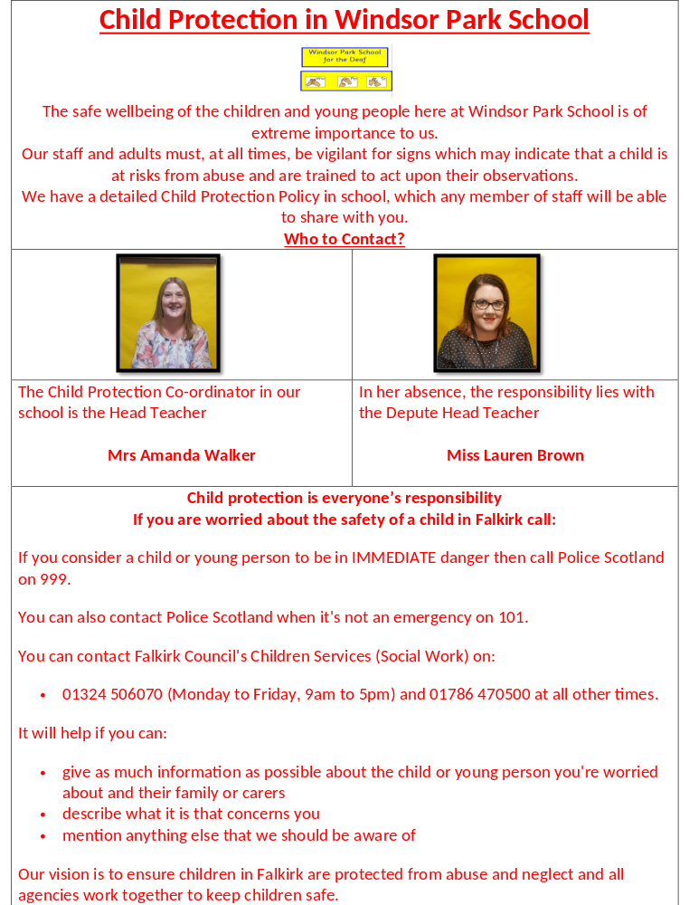

- Focused programmes

Children and young people at Windsor Park will experience certain aspects of health and wellbeing through focused programmes;

- Swimming with British Sign Language instructor
- First Aid with British Sign Language instructor
- Cycling Proficiency
- Relax Kids
- Drama delivered by British Sign Language specialists
- Outdoor Education

Within these programmes, we will often draw on the expertise of others. For example, when substance misuse is being considered, specialists within and outwith the learning community working together are able to ensure that children and young people learn in the most effective ways. At Windsor Park we have access to Food Technology teacher and Physical Education specialist who play a very important role in the teaching and learning of health and wellbeing through the experiences and outcomes for food and health, and physical education, physical activity and sport. Sports specialists, such as Forth Valley Disability Sports and British Deaf Association, play an important part in physical activity and sport provision for our D/deaf children and young people.

- Partnership working across sectors and services
Windsor Park School pride ourselves on our partnership working as we recognise the benefits in our D/deaf children’s and young people’s learning in health and wellbeing. Windsor Park staff work in partnership with Teachers of the Deaf from across Scotland, mainstream teachers and colleagues, health professionals such Speech and Language Therapist, NHS Dental Team, our assigned Educational Psychologists, Lloyds Banking, Forth Valley Sensory Centre, Relax Kids, the Deaf Roots and Pride team at British Deaf Association and our Outdoor Education instructor who can make complementary contributions through their specialist expertise and knowledge.

- Personal support for children and young people
At Windsor Park, each Teacher of the Deaf is assigned specific children who is responsible for the health and wellbeing of every child in their care. We recognise this is greatly enhanced through the individual support and pastoral care which they receive through having a consistent Teacher of the Deaf and Support for Learning Assistant who know and understand them and can support them in facing changes and challenges and in making choices. These staff are often best placed to identify even minor changes of mood in our children or young people which could reflect an important emotional, social or mental health issue with which that child or young person needs help or support. Each child is welcomed into school and time is taken at the start of each day to ensure we are all ready to learn. This dedicated time at the start of each day is important for our children and young people to feel that they can share their anxieties with an appropriate individual who has the skills, rapport, responsibility and the time to listen and to help, or can identify appropriate sources of support. Our Senior Leadership Team, Teachers of the Deaf and Support for Learning Assistants all work together to ensure the best support is given to our D/deaf children and young people.

- What factors need to be taken into account in planning for Health and Wellbeing at Windsor Park?

At Windsor Park School, we recognise and appreciate D/deaf children and young people’s capacities to learn are shaped by their background and home circumstances as well as by their individual development. Teachers of the Deaf are aware exposure to different social and environmental influences contribute to the way that attitudes, values and behaviours are formed. These in turn affect their ability to make and take decisions. Windsor Park staff build this into the learning across our school.

Windsor Park staff understand progression and development in many aspects of health and wellbeing will depend upon the stage of growth, development and maturity of the individual, upon social issues and upon the community context. Our Teachers and SfLAs will take account of these factors, ensuring that experiences are relevant and realistic for the child or young person in his or her circumstances. Particularly within experiences and outcomes which span more than one level, careful planning will be required to ensure appropriate pace and coverage, and our teachers will need to decide when and how the experiences and outcomes are introduced, taking into consideration the learning style and communication mode of the young people they are teaching.

The knowledge, skills and attitudes identified within the various aspects of the health and wellbeing experiences and outcomes are interrelated; teachers and other practitioners will plan and present learning in ways that enable learners to see them as closely linked and where appropriate, bundle with other curricular areas.
The experiences and outcomes support learning which is challenging and enjoyable; they provide the necessary breadth and depth to meet the needs of all learners; they ensure that account is taken of individual and our context as a School for the Deaf. Windsor Park staff recognise the flexibility of the experiences and outcomes to plan health and wellbeing programmes which take account of local needs and are innovative, use relevant learning contexts and ensure coherence and progression. All aspects of health and wellbeing, including events, are planned as part of a whole school strategy, to ensure that they have sustained impact.

- What features are required to effectively promote Health and Wellbeing at Windsor Park?

Effective learning through health and wellbeing which promotes confidence, independent thinking and positive attitudes and actions requires:

Leadership which:
• establishes a shared vision of health and wellbeing for all
• is open, collaborative and responsive
• engages and works with parents and carers and all stakeholders to provide children and young people with coherent and positive experiences which promote and protect their health
• promotes the health of all within the school community and develops arrangements to support their mental, social, emotional and physical wellbeing
• responds sensitively and appropriately if a critical incident takes place within the school community, and has contingency plans in place to enable this to happen.

Partnership working which:
• engages the active support of parents and carers
• reinforces work across transitions and cluster planning across sectors
• maximises the contributions of the wider community
• draws upon specialist expertise
• ensures, through careful planning and briefing, that all contributions come together in ways which ensure coherence and progression.

Learning and teaching which:
• engages children and young people and takes account of their views and experiences, particularly where decisions are to be made that may impact on life choices
• takes account of research and successful practice in supporting the learning and development of children and young people, particularly in sensitive areas such as substance misuse
• uses a variety of approaches including active, cooperative and peer learning and effective use of technology
• encourages and capitalises on the potential to experience learning and new challenges in the outdoor environment
• encourages children and young people to act as positive role models for others within the educational community
• leads to a lasting commitment in children and young people to follow a healthy lifestyle by participation in experiences which are varied, relevant, realistic and enjoyable
• helps to foster health in families and communities through work with a range of professions, parents and carers, and children and young people, and enables them to understand the responsibilities of citizenship
• harnesses the experience and expertise of different professions, including developing enterprise and employability skills, alongside empowering young people of their rights as a D/deaf adult.

- What are the broad features of assessment in Health and Wellbeing?

As important aspects of health and wellbeing are the responsibility of all staff in Windsor Park in partnership with others, and because of the importance of health and wellbeing to learning and development, everyone is clear about their areas of responsibility and their roles in assessment. In health and wellbeing, assessment has to take account of the breadth and purpose of the wide range of learning experienced by children and young people within this curriculum area. It will focus on children and young people’s knowledge and understanding, skills and attributes in relation to physical education, food and health, substance misuse, relationships, sexual health and parenthood, and their social and life skills.

Teachers of the Deaf, Support for Learning Assistants and learners can gather evidence of progress as part of day-to-day learning inside and outside the classroom and, as appropriate, through specific assessment tasks such as Boxall profiling. From the early years through to the senior stages, D/deaf children and young people’s progress will be seen in how well they are developing and applying their knowledge, understanding and skills in, for example, key features of healthy living and relationships, and in approaches to personal planning, assessing risk and decision making.

For example:

• To what extent do they understand the role of healthy eating and physical fitness in contributing to their wellbeing?
• How well are they applying personal and interpersonal skills as part of their daily lives, and developing them as they grow and mature?
• Through their involvement in planning, managing and participating in individual and group activities in school and in the hearing and D/deaf community, do they demonstrate skills, attitudes and attributes which will be important for the world of work, such as judgement, resilience and independence?

Progression in knowledge, understanding and skills can be seen as children and young people demonstrate that they are:
• applying their knowledge and skills with increasing confidence and competence in dealing with familiar circumstances and new challenges
• developing an increasing depth of understanding of their own and others’ motivations, attitudes, beliefs and behaviours
• extending the range of their relationships within and outwith the school.

Assessment also links with other areas of the curriculum, within and beyond the classroom, offering D/deaf children and young people opportunities to apply their knowledge and skills in more complex, demanding or unfamiliar learning or social contexts.

- How is personal safety addressed at Windsor Park?

At Windsor Park we consider each organiser within health and wellbeing and plan learning experiences which include relevant aspects of personal safety with the additional impact of their deafness: for example travelling safely, responses in emergencies, food safety, substance misuse and safety in relationships. In partnerships with National Deaf Children’s Society and Forth Valley Sensory Centre, the children and their families are supported in ensuring specific aids are present in the home to promote independence in personal safety such as flashing smoke alarms, ways to contact emergency services when you are D/deaf and their rights to a British Sign Language interpreter to access support.

- What is the contribution of physical education, physical activity and sport to Health and Wellbeing?

Regular physical activity is essential for good health and our children and young people receive at least two hours of physical education each week. Physical education is delivered by specialist teaching staff from Falkirk High School and Bantaskin Primary. Lessons taught should inspire and challenge children and young people to experience the joy of movement, to develop positive attitudes both individually and as part of a group and to enhance their quality of life through active living. This will give our children and young people an important foundation for participation in experiences in physical activities and sport and in preparation for a healthy and fulfilling lifestyle. Our children and young people will participate in and enjoy physical activity and sport, in addition to planned physical education sessions, at break times and lunchtimes, during travel and beyond the school day.
Windsor Park recognise the challenges our D/deaf children and young people have in developing cycling and swimming skills due to their deafness. Each session our whole school attend specialist swimming lessons, taught by a swimming instructor with an additional British Sign Language qualification. We have established partnerships with George Callaghan, who will work with our staff to deliver 1:1 session to ensure all our children can cycle and then work in small groups to build confidence and a love of cycling. Outdoor learning has been a huge area of development for Windsor Park in session 19/20 and will continue to be on our School Improvement Plan in session 2020/2021 to allow it to embed into everyday practice. Outdoor Education can contribute to physical activity and enhance learning in different areas of the curriculum.

Taken together, the experiences and outcomes in physical education, physical activity and sport aim to establish the pattern of daily physical activity which, research has shown, is most likely to lead to sustained physical activity in adult life and we wish to continue to promote that here at Windsor Park.

- How can a whole school approach to food and health contribute to Health and Wellbeing?

Here at Windsor Park we recognise our contribution to improving our children’s diets through the promotion of consistent healthy eating messages enabling them to make healthy food choices and to develop lifelong healthy eating habits. A good diet is essential for good health. Research shows that many children fall short of national dietary recommendations. A poorly balanced diet can contribute to the risk of developing a number of diseases and conditions including tooth decay, obesity, certain cancers, diabetes, coronary heart disease and stroke.

Hungry for Success encouraged the adoption of a whole school approach to food and health. This approach is now reinforced through the Schools (Health Promotion and Nutrition) (Scotland) Act 2007 and forms the basis of this framework for food and health. At Windsor Park, we learn how o plant and grow produce, alongside the partnerships we have with Forth Valley Sensory Centre and Lloyds Banking. We harvest our produce and plan and prepare healthy foods practical foods. Our pupils have a variety of opportunities to apply their knowledge and skills to plan and safely prepare dishes for a healthy balanced diet to meet their own needs and the needs of others. In this way they have gained an appreciation that preparing and eating food can be a pleasant, enjoyable and social experience, in line with Curriculum for Excellence.

- How do Windsor Park staff make connections within and beyond Health and Wellbeing?

Staff at Windsor Park recognise the health and wellbeing experiences and outcomes are designed to encourage links with all other areas of the curriculum, to reinforce learning and to provide relevant, enjoyable and active experiences.

• The health and wellbeing experiences and outcomes provide valuable opportunities to develop skills in literacy and numeracy.
• There are important links between health and wellbeing, and religious and moral education in the establishment of values and growth of spiritual wellbeing, and in considering relationships. Windsor Park often involve the children in planning visits to places of worship to promote awareness of safety when travelling and giving them confidence to express their preferred mode of communication with a hearing world.
• Participation in expressive arts activities can make an important contribution to a child’s or young person's sense of wellbeing and can bring learning to life. Using the expressive arts as a medium for learning, for example through role play, can engage learners in issues such as bullying, in more engaging and accessible ways. Windsor Park has fostered partnerships with two graduates from Royal Conservatoire of Scotland who teach drama through British Sign Language, also promoting positive destinations for our children and young people.
• There are very close connections between dance and physical education, in particular through the shared outcomes in evaluating and appreciating.
• There are clear connections between science and several aspects of health and wellbeing; between the technologies and, for example, food and health; and between the social studies and the aspects relating to citizenship and participation.

In all of these cases staff at Windsor Park have the scope to group experiences and outcomes together in different and imaginative ways which enrich, consolidate and enhance progression in learning in Deaf Education.

16 . Summary
In summary, at Windsor Park School we recognise childhood and adolescence are critical periods for developing attitudes, skills and knowledge for living a healthy life. Windsor Park staff plan and implement learning experiences which inform choices and deepen understanding of what constitutes good health choices. Windsor Park presents learning opportunities that build upon family/cultural experiences and allow for critical analysis of media, advertising and peer conformity. At Windsor Park, we have a responsibility to teach, model, build behaviour practices and implement curriculum requirements that support a learning environment where the connection of learning about health and wellbeing is supported by alignment of action across a whole school approach in ensuring our children and young people are able to live their best lives.

